Hands on 1
Spring Data JPA - Quick Example
MODEL : 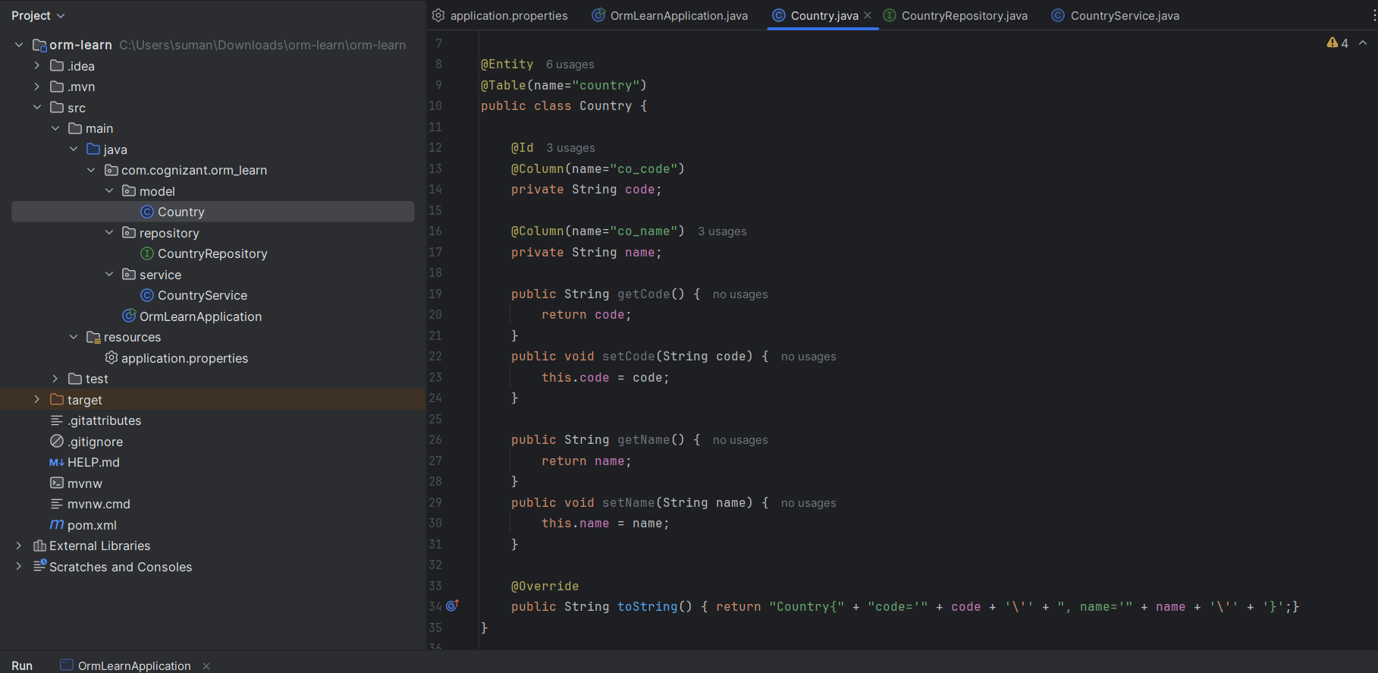

SERVICE :
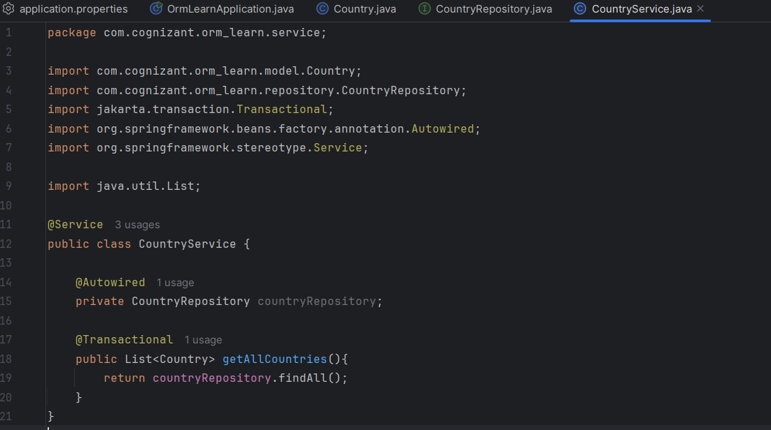

REPOSITORY:
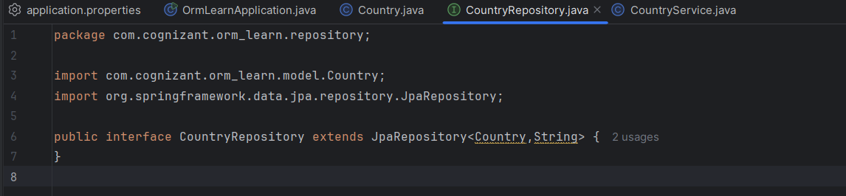

MAIN :
